AWS Certification

Amazon Web Services (AWS), the popular [cloud](https://www.edureka.co/blog/what-is-cloud-computing/) platform, houses a collection of cloud computing services. AWS has more than 70 services, spanning a wide range, including compute, storage, networking, database, analytics, application services, deployment, management, mobile, developer tools and Internet of things.

 There are five different certifications and each of them open the floodgates to enhanced career opportunities.

**AWS suite of certifications**

AWS certifications are aligned to two broad streams – Solutions Architect and DevOps Engineer. The Solutions Architect stream is well defined; you should first bag the Solutions Architect – Associate certification followed by the Solutions Architect – Professional certification. But if you choose to certify yourself as an AWS DevOps Engineer, you have to either clear the Developer – Associate certification or the System Operations (SysOps) Administrator – Associate certifications. Of course, you should choose based on your current job or the stream of specialization you aspire for.

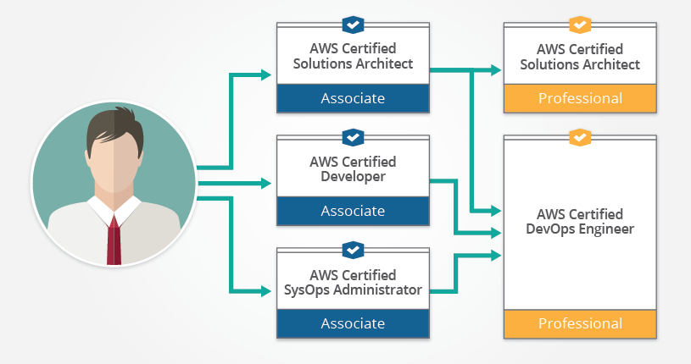

I have good news for you. The associate certifications of Solutions Architect and Developer share 50% content between them. So if you prepare for one, you’ve pretty much prepared half of the other as well. While most people I’ve met feel that Developer is the easiest to crack, Solutions Architect makes you a master of almost all of AWS’ services and helps you understand all key concepts. SysOps, on the other hand, is an ideal starting point if you are currently working as an infrastructure/system admin and/or are managing VMs, storage or networking in your current job. furnish any proof of experience. Let me now explain what you will achieve with each of these certifications:

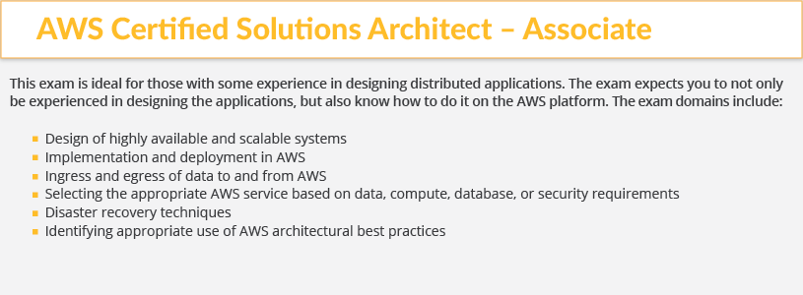

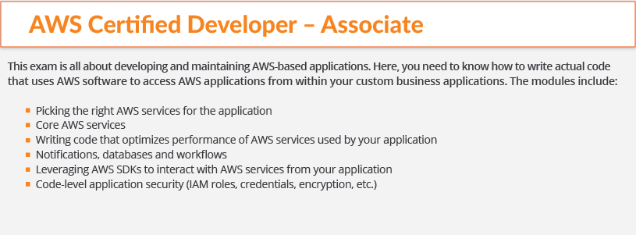

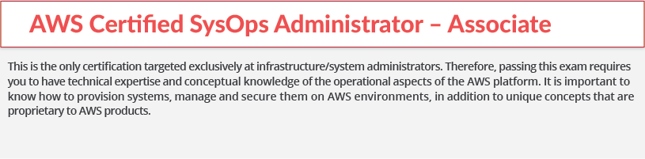

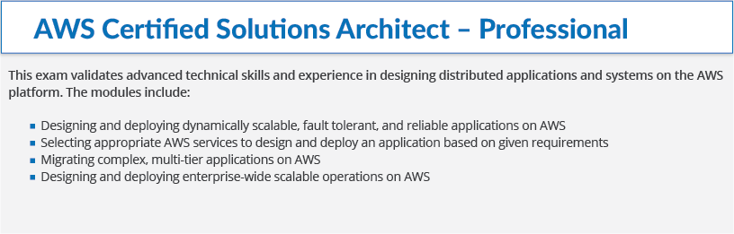

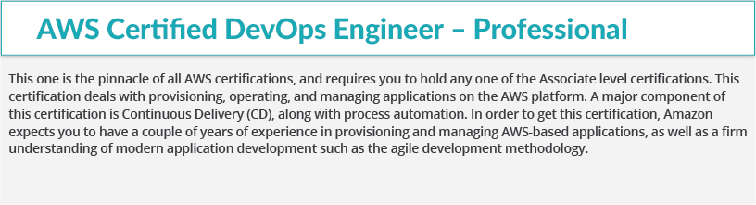



## ****Introduction****

**What is AWS? – Amazon Web Services(AWS)** is a cloud service from Amazon, which provides services in the form of building blocks, these building blocks can be used to create and deploy any type of application in the cloud.

These services or building blocks are designed to work with each other, and result in applications, which are sophisticated and highly scalable.

Each type of service in this “What is AWS” blog, is categorized under a domain, the few domains which are widely used are:

* Compute
* Storage
* Database
* Migration
* Network and Content Delivery
* Management Tools
* Security & Identity Compliance
* Messaging

The **Compute** domain includes services related to compute workloads, it includes the following services:

* EC2 (Elastic Compute Cloud)
* Lambda
* Elastic Beanstalk
* Amazon LightSail

The**Storage**domain includes services related data storage, it includes the following services:

* S3 (Simple Storage Service)
* Elastic Block Store
* Amazon Glacier
* AWS Snowball

The **Database**domain is used for database related workloads, it includes the following services:

* Amazon Aurora
* Amazon RDS
* Amazon DynamoDB
* Amazon RedShift

The **Migration** domain is used for transferring data to or from the AWS Infrastructure, it includes the following services:

* AWS database Migration Service
* AWS SnowBall

The**Networking and Content Delivery** domain is used for isolating your network infrastructure, and content delivery is used for faster delivery of content. It includes the following services:

* Amazon Route 53
* AWS CloudFront

The **Management Tools** domain consists of services which are used to manage other services in AWS, it includes the following services:

* AWS CloudWatch
* AWS CloudFomation
* AWS CloudTrail

The **Security & Identity, Compliance** domain consist of services which are used to manage to authenticate and provide security to your AWS resources. It consists of the following services:

* AWS IAM
* AWS KMS
* AWS Shield

The **Messaging** domain consists of services which are used for queuing, notifying or emailing messages. It consists of the following domains:

* Amazon SQS
* Amazon SNS
* Amazon SES
* Amazon Pinpoint

Keeping that in mind, let’s understand how does one build applications in AWS:

## Building Applications

* First and foremost, you should analyze, what is your application about? Is it something that requires you to be worried about the underlying infrastructure? Is it something that requires a database? Is it something which will require monitoring?
* So, once you know all the requirements about your application, you can pick the domain, and hence choose a service.
* Like for example, you want to deploy an application in AWS, which does not require you to worry about the underlying architecture, which service will you choose?
* Well, in the compute section there is this service called Elastic Beanstalk. You just upload your application, and AWS does the rest for you. It’s that simple!
* Of course you wouldn’t know about any of these services without using them right? That’s why AWS came up with an amazing free tier option.

## ****Demo****

We will be creating a small application on EC2-RDS infrastructure in this What is AWS blog. By the end, you will have a PHP application on EC2, backed by a fully managed MySQL server.

**Let’s start by deploying an EC2 instance first in this What is AWS blog.**

**Step 1:**Login to AWS Management Console.

Create Windows Ec2 instance

Step-2: **Let’s create a RDS instance for MySQL**

**Step 3 :**

In the next step, you will be configuring Advanced Settings for your DB

* You will be selecting the VPC here, if you do not wish to launch your instance in a VPC you can leave the default settings and move ahead.
* In the next section you can select which version of the Db you want to use, for our example we are using MySQL 5.6
* In the next section you can set your backup preferences, like the retention period etc.
* After that we will be setting the maintenance window, this is the time frame during which your Db instances will be updated.
* Once you fill all the details, you will be launching the Db instance!

## What is AWS?

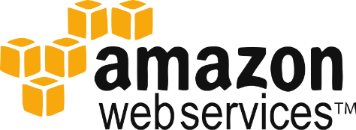

Amazon Web Services(AWS) is a Amazon.com subsidiary which offers**cloud-computing services**at very affordable rates, therefore making its customer base strong from small scale companies like Pinterest (which has just 5 employees) to big enterprises like D-Link.

## What is Cloud Computing?

It is the use of remote servers on the internet to store, manage and process data rather than a local server or personal computer.

There are basically 3 categories in cloud computing:

* **SaaS (Software as a Service)**
  + It allows companies to use software without having to purchase them, which reduces the expenditure of the company drastically, since they are already installed on the cloud server they can be quickly deployed and therefore saves time.
* **PaaS (Platform as a Service)**
  + It allows developers to build applications, collaborate on projects without having to purchase or maintain infrastructure.
* **IaaS (Infrastructure as a Service)**
  + It allows companies to rent servers, storage space, etc. from a cloud provider.

When we talk about AWS, it’s more of an IaaS, moving along, let’s take a deep dive into AWS and understand what all services it has to offer us, but before that lets understand why there is a lot of buzz in the industry about AWS which therefore led to this awesome AWS Tutorial!

## Compute

* **AWS EC2**It is a web service which provides re-sizable compute capacity in the cloud. It is designed to make the web scale computing easier for developers. To know more about the service you can refer to our AWS EC2 blog. To know more, please go through the [AWS EC2 blog](https://www.edureka.co/blog/ec2-aws-tutorial-elastic-compute-cloud/-elastic-compute-cloud)
* **AWS Elastic Beanstalk**  
  Elastic Beanstalk lets you quickly deploy and manage applications in AWS without worrying about the underlying infrastructure.

* **AWS Elastic Load Balancing  
  **  
  ELB automatically manages the workload on your instances and distributes them to other instances in case of an instance failure.

* **AWS Lambda  
  **  
  AWS Lambda is used to execute backend code without worrying about the underlying architecture, you just upload the code and it runs, it’s that simple! To know more, please go through the[AWS Lambda Blog](https://www.edureka.co/blog/aws-lambda-tutorial)
* **AWS Autoscaling**  
  
* The Autoscaling feature is used to scale up and down automatically as and when required. To know more, please go through the [AWS EC2/Autoscaling Blog](https://www.edureka.co/blog/ec2-aws-tutorial-elastic-compute-cloud/-elastic-compute-cloud)

* **Storage and Content Delivery**
* **S3 AWS  
  **  
  S3 stands for simple storage service, it is used for storing data in the form of objects in the AWS Cloud. To know more about S3, please go through the [S3 AWS Blog](https://www.edureka.co/blog/s3-aws-amazon-simple-storage-service/)

* **Amazon CloudFront**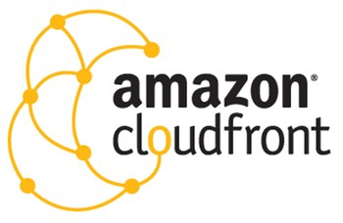  
  CloudFront is a content delivery network which is used to cache data to an edge location which reduces latency. To know more about Amazon Cloudfront, please go through the [S3 AWS/CloudFront Blog](https://www.edureka.co/blog/s3-aws-amazon-simple-storage-service/)
* **Amazon EBS**[](https://www.edureka.co/blog/ec2-aws-tutorial-elastic-compute-cloud/-elastic-compute-cloud#ebs)

Amazon Elastic Block Storage is a storage service wherein each block of storage acts like a separate hard drive. To know more about EBS, please refer our[AWS EC2/EBS Blog](https://www.edureka.co/blog/ec2-aws-tutorial-elastic-compute-cloud/-elastic-compute-cloud)

* **Amazon Glacier**  
  Glacier is an archiving service offered by Amazon, which offers low cost data archiving. To know more about Amazon Glacier, please refer our [S3 AWS/Glacier Blog](https://www.edureka.co/blog/s3-aws-amazon-simple-storage-service/)
* **AWS Import/Export Snowball**  
    
  It offers physical transfer of data between user’s location and AWS data centers, the device which is used to transfer the data is called Snowball. To know more about AWS Snowball, please refer out [S3 AWS/Snowball Blog.](https://www.edureka.co/blog/s3-aws-amazon-simple-storage-service/)

* **AWS Storage Gateway**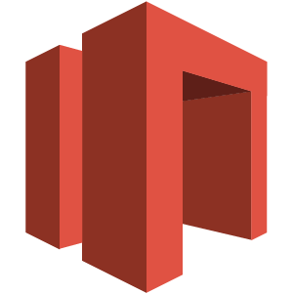  
  It is used to provide seamless integration with data security features between your on premise software appliance and AWS Cloud.

## Database

* **Amazon Aurora**  
  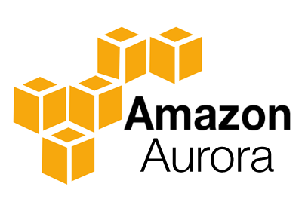

It is a relational database engine that combines the speed and reliability of high-end commercial databases and the cost effectiveness and simplicity of open-source databases.

* **Amazon RDS**Amazon RDS is a managed relational database service which does routine database tasks  in 6 familiar databases like  Amazon Aurora, MySQL, MariaDB, Oracle, Microsoft SQL Server, and PostgreSQL. To know more, please refer our [RDS AWS Blog.](https://www.edureka.co/blog/rds-aws-tutorial/)

* **Amazon DynamoDB  
  **

It is a fully managed No-SQL database service. It is known for extremely low latencies and scalability.

* **Amazon ElastiCache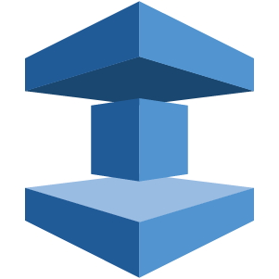**It is a web service that makes it easy to set up, manage and scale a distributed cache-in environment in the cloud.

* **Amazon Redshift  
  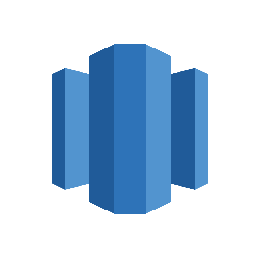**

Amazon Redshift is a fully managed petabyte-scale data warehouse service in the cloud.

## Networking

* **VPC AWS**Amazon VPC lets you launch AWS resources in a virtual network that you define. It closely resembles a traditional network that you’d operate in your data center.

* **AWS Direct Connect  
  **

It helps you establish a private connection between your premises and AWS, therefore giving better network performance and throughput than an Internet based connection.

* **Amazon Route 53**Route 53 is a highly scalable and highly available Domain Name System by Amazon AWS. The name is in reference to the TCP and UDP’s port 53 where DNS requests are addressed.

## Management Tools

* **Amazon CloudWatch**  
  

It is a monitoring tool by AWS which is used to keep a track on the AWS resources and the applications you run on Amazon AWS.

* **AWS CloudFormation**  
  It is a service which helps you setup and model your Amazon AWS resources so that you can spend less time managing these resources and more time focusing on the development.

* **AWS CloudTrail**



AWS CloudTrail is a logging service which records the API calls to your Amazon AWS account and delivers them to you.

* **AWS Command Line Tool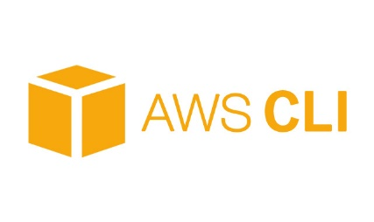**It is an all in one tool to manage all your AWS services, by downloading and configuring only one tool you can manage all the AWS services through the command line.

* **AWS OpsWorks**

It is a configuration management tool that helps configure and operate applications of all size and shapes using Chef.

* **Trusted Advisor**Trusted Advisor is a customized cloud monitoring tool, that analyzes your AWS environment and gives insights on the expense, performance improvement, security gaps and reliability.

## Security and Identity

* **AWS Identity and Access Management(IAM)**  
  

It is an AWS service that helps you control access to your AWS resources for your users.

* **AWS Key Management Service**It is a managed service that helps you create and control encryption keys which is used to encrypt your data, and uses Hardware Security Modules to protect the security of your keys.

## Application Services

* **Amazon SES**  
  

It is a cost effective emailing service which is built on the scalable and reliable infrastructure of Amazon.com

* **Amazon SNS**  
  It is a web service offered by AWS that manages the delivery of messages to subscribed **endpoints or clients.**
* **Amazon SQS**

It is a fast, reliable and scalable message queuing service, it can be used to transmit any volume of data at any level of throughput, without losing any messages or without the use of any other service.